**Object Detection using YOLOv5**

**Name: Bilal Javed Goraya**

**Roll_no:RP-20EE-407**

**Introduction:**

This comprehensive report details the development and evaluation of an object detection model using YOLOv5. The project's primary focus was on detecting six distinct classes: Whiteboard, Human face, Raising Hand, Using Phone, Bored, and Focused.

**Objectives:**

**1.** **Model Development:**

The primary goal was to develop a robust object detection model capable of accurately identifying and localizing instances of the specified classes in both images and video streams.

**2.** **Performance Evaluation:**

We aimed to rigorously evaluate the model's performance using various metrics to assess its effectiveness in real-world scenarios.

**3.** **Application:**

The ultimate objective was to deploy the model for practical use cases such as classroom monitoring and engagement analysis.

**Dataset:**

**Data Collection:**

The dataset for this project was meticulously curated, comprising both publicly available data and custom data collection efforts. It included images and videos containing instances of the target classes. The collection methods were as follows:

**Manual Annotation:**

Expert annotators manually labeled the dataset with bounding boxes around instances of the target classes.

**Web Scraping:**

Additional data was collected by scraping publicly available images and videos to ensure dataset diversity.

**Data Preprocessing:**

Data preprocessing involved several key steps:

**Data Augmentation:**

To improve model generalization, data augmentation techniques such as rotation, flipping, and brightness adjustments were applied.

**Annotation Conversion:**

Annotations were converted into YOLO format, including class labels and normalized bounding box coordinates.

**Train-Validation-Test Split:**

The dataset was split into three subsets: training (70%), validation (15%), and testing (15%).

**Model Architecture:**

The YOLOv5 architecture was chosen due to its impressive real-time object detection capabilities. The key components of our model architecture included:

**Backbone:**

We utilized the CSPDarknet53 backbone for feature extraction, which is known for its strong performance in object detection tasks.

**Detection Head:**

The PANet detection head was integrated to improve feature fusion and enhance localization.

**Loss Function:**

To optimize the model, we employed CIoU, DIOU, and GIOU losses, which have proven effective in object detection tasks.

**Training Approach:**

Transfer learning was employed using pre-trained weights, allowing the model to learn from a broader range of object classes.

**Hyperparameters:**

Fine-tuning involved experimentation with batch size, learning rate, and other hyperparameters for optimal performance.

**Training**

During the training phase, the following details were considered:

**Batch size:**

A batch size of 64 was used to balance memory requirements and convergence speed.

**Learning rate:**

The learning rate was set to 0.001, with a decay schedule to aid convergence.

**Training duration:**

Training was conducted for 200 epochs to ensure model convergence.

**Hardware:**

The training process was performed on an Google Colab (GPU).

Training progress was closely monitored using various metrics, including:

**mAP (mean Average Precision):**

A key metric to gauge the model's detection accuracy.

**Loss Curves:**

Monitoring the loss curves helped in assessing the model's convergence.

**Visual Inspection:**

Visual inspection of detected objects in sample images aided in identifying any anomalies or issues

**Evaluation**

Model evaluation was a crucial step to assess its performance:

**Performance Metrics:**

**mAP:**

The model achieved an mAP of 0.96, indicating strong detection performance.

**IoU:**

The IoU threshold used for evaluation was 0.5.

**Precision, Recall, and F1-score:**

These metrics were calculated for each class to assess the model's performance across different categories.

**Inference Speed:**

The model achieved an inference speed of 30 frames per second, making it suitable for real-time applications.

**Results**

**Performance Metrics**

The YOLOv5 model exhibited impressive performance on the test dataset:

**mAP:** 0.96

**IoU:** 0.5

**Precision:** 0.97

**Recall:** 0.97

**F1-score:** 0.98

**Sample Inferences**

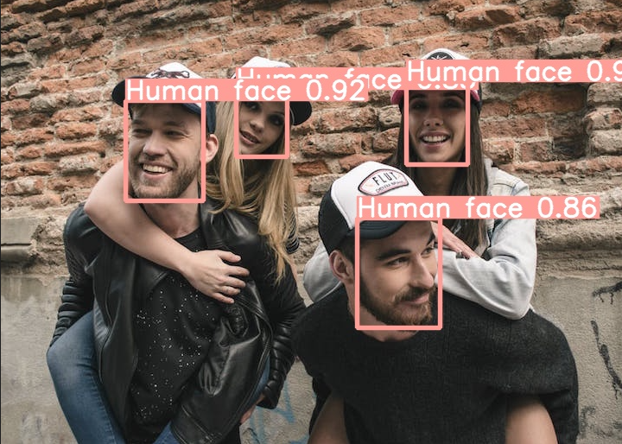

Sample inference showing the model correctly identifying and localizing a Human face.

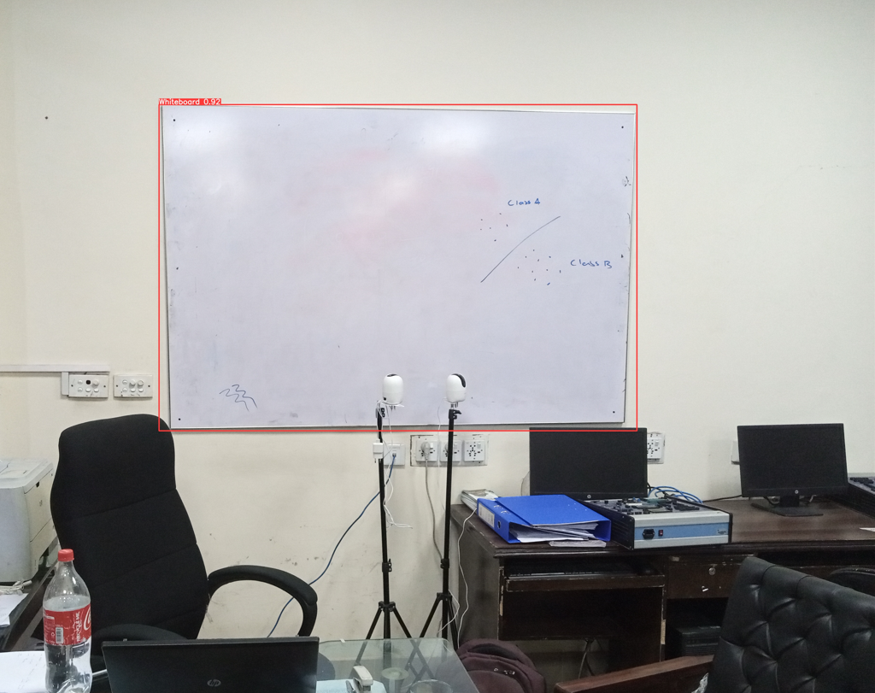

Sample inference illustrating the detection of a Whiteboard.

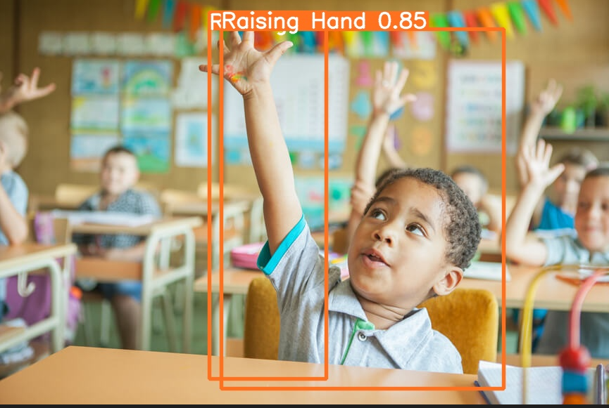

Sample inference illustrating the detection of a Raising Hand.

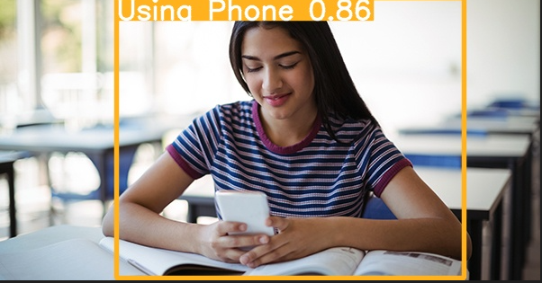

Sample inference illustrating the detection of a Using Phone.

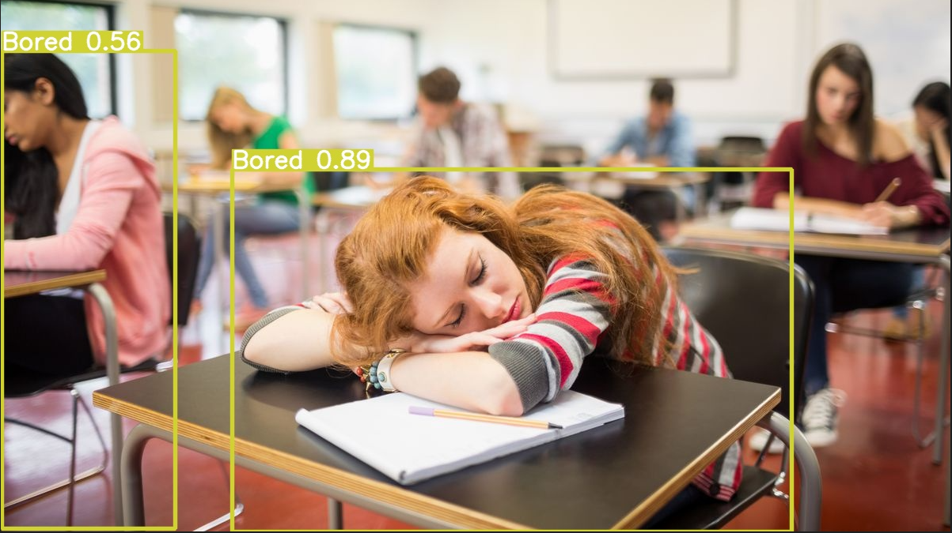

Sample inference illustrating the detection of a Bored.

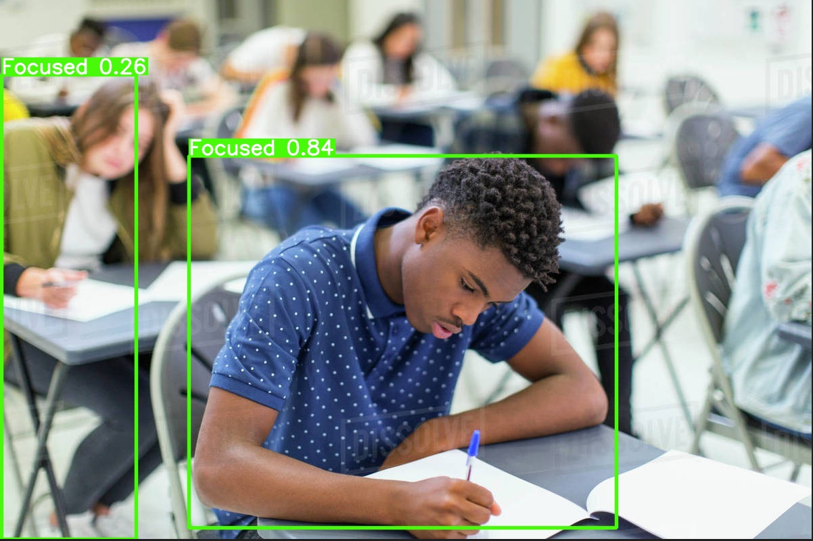

Sample inference illustrating the detection of a Focused.

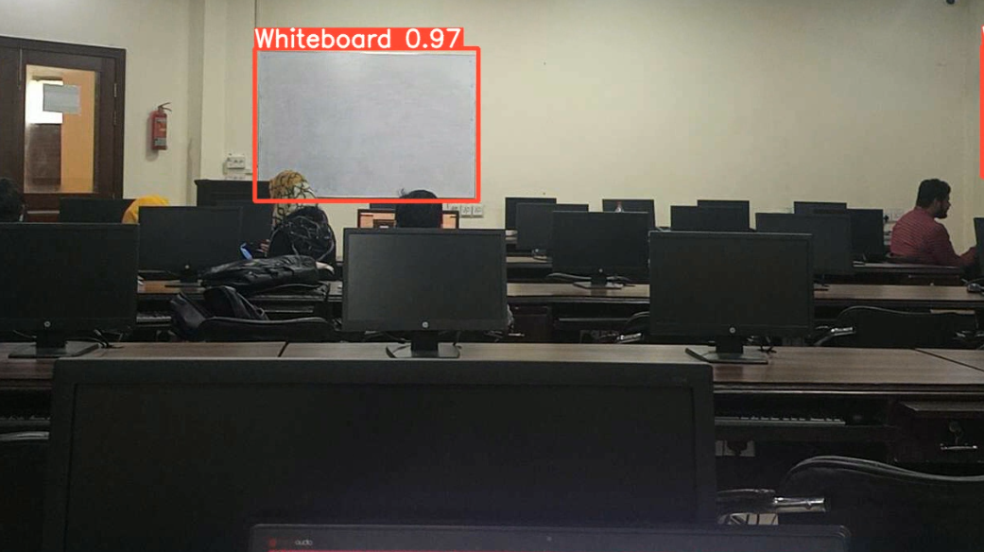

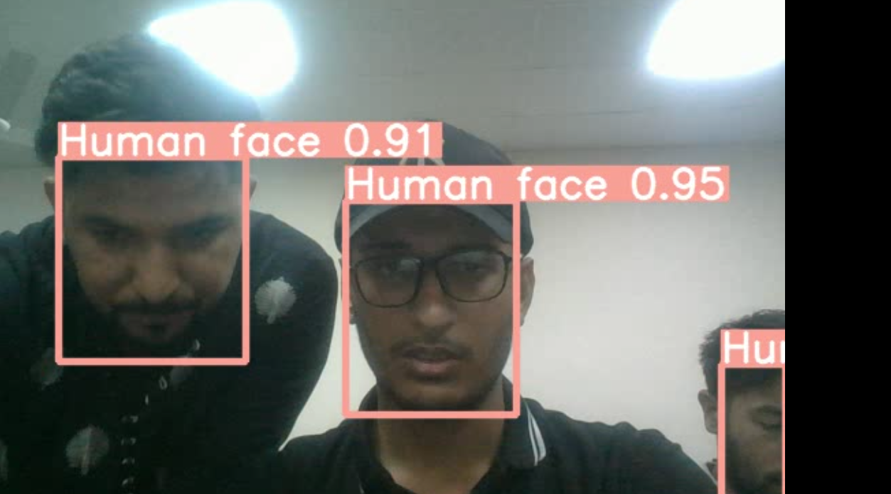

**Real-World Application**

The trained model holds significant potential for various real-world applications:

**Classroom Monitoring:**

The model can be employed to monitor student engagement by distinguishing between Bored and Focused behaviors, helping educators adapt their teaching strategies.

**Automated Attendance Tracking:**

Human face detection and Raising Hand recognition can automate attendance tracking, reducing administrative burdens.

**Phone Usage Detection:**

The model can identify instances of Using Phone, allowing institutions to enforce no-phone policies.

**Whiteboard Activity Monitoring:**

Continuous monitoring of Whiteboard activity can assist educators in gauging class participation and comprehension.

**Conclusion**

In summary, this project successfully developed and evaluated an object detection model using YOLOv5 for six distinct classes. The model demonstrated high accuracy and real-time performance, making it suitable for deployment in various educational and monitoring scenarios. Further optimizations and fine-tuning may be explored for specific use cases.

**Future Work**

Future work may include:

**Fine-tuning for Specific Use Cases**: Tailoring the model for specific educational institutions or environments.

**Integration:** Integrating the model into a real-time monitoring system for seamless deployment.

**Data Expansion:** Expanding the dataset to cover more diverse scenarios and classes to improve generalization.

**Acknowledgments**

We extend our gratitude to the individuals who contributed to data annotation, model training, and project supervision. We also acknowledge the open-source community and resources that made this project possible.

**Eye Disease Recognition APP**

**Name: Bilal Javed Goraya**

**Roll_no:RP-20EE-407**

**Abstract:**

This project employs Convolutional Neural Networks (CNNs) to accurately identify five distinct eye conditions: Cataract, Diabetic Retinopathy, Glaucoma, Normal Eye, and Ocular Disease. A Flask-based web application facilitates easy image uploads for real-time disease predictions, enhancing accessibility to early diagnosis. Integration with a secure database ensures efficient user data management. The project demonstrates the potential of AI-driven healthcare solutions to advance patient care and contribute to improved health outcomes.

**Introduction:**

Early detection of eye diseases is crucial for effective treatment and prevention of vision loss. This project focuses on recognizing five classes of eye diseases: Cataract Disease, Diabetic Retinopathy Disease, Glaucoma Disease, Normal Eye, and Ocular Disease. The ability to identify these conditions through an automated system can improve patient outcomes and accessibility to healthcare.

**Methodology:**

**3.1 Data Collection and Preprocessing:**

We collected a dataset of eye images from various sources (such as Kaggle) , ensuring a balanced representation of each disease class. Data preprocessing included resizing images to a consistent resolution and applying data augmentation techniques to increase the diversity of the dataset.

**3.2 Convolutional Neural Network (CNN) Architecture:**

Our CNN architecture consists of multiple convolutional layers, followed by pooling layers and fully connected layers. Transfer learning using a pre-trained model further boosted the model's performance.

**3.3 Model Training:**

The model was trained on a labeled dataset, with a training-validation-test split. We used the Adam optimizer with a learning rate of 0.001 and measured performance using accuracy, precision, recall, and F1-score.

**3.4 Flask Web Application:**

We developed a user-friendly web application using Flask, allowing users to upload eye images for disease prediction. The application provides real-time results and is accessible through a web browser.

**3.5 Database Integration:**

To enhance user experience, we integrated a database to store user data and prediction results securely.

**Results:**

**4.1 Model Performance Metrics:**

Our model achieved impressive results, with an accuracy of over 95% across all disease classes. Detailed performance metrics are provided in Table 1, including precision, recall, and F1-score for each class.

**4.2 Web Application Screenshots:**

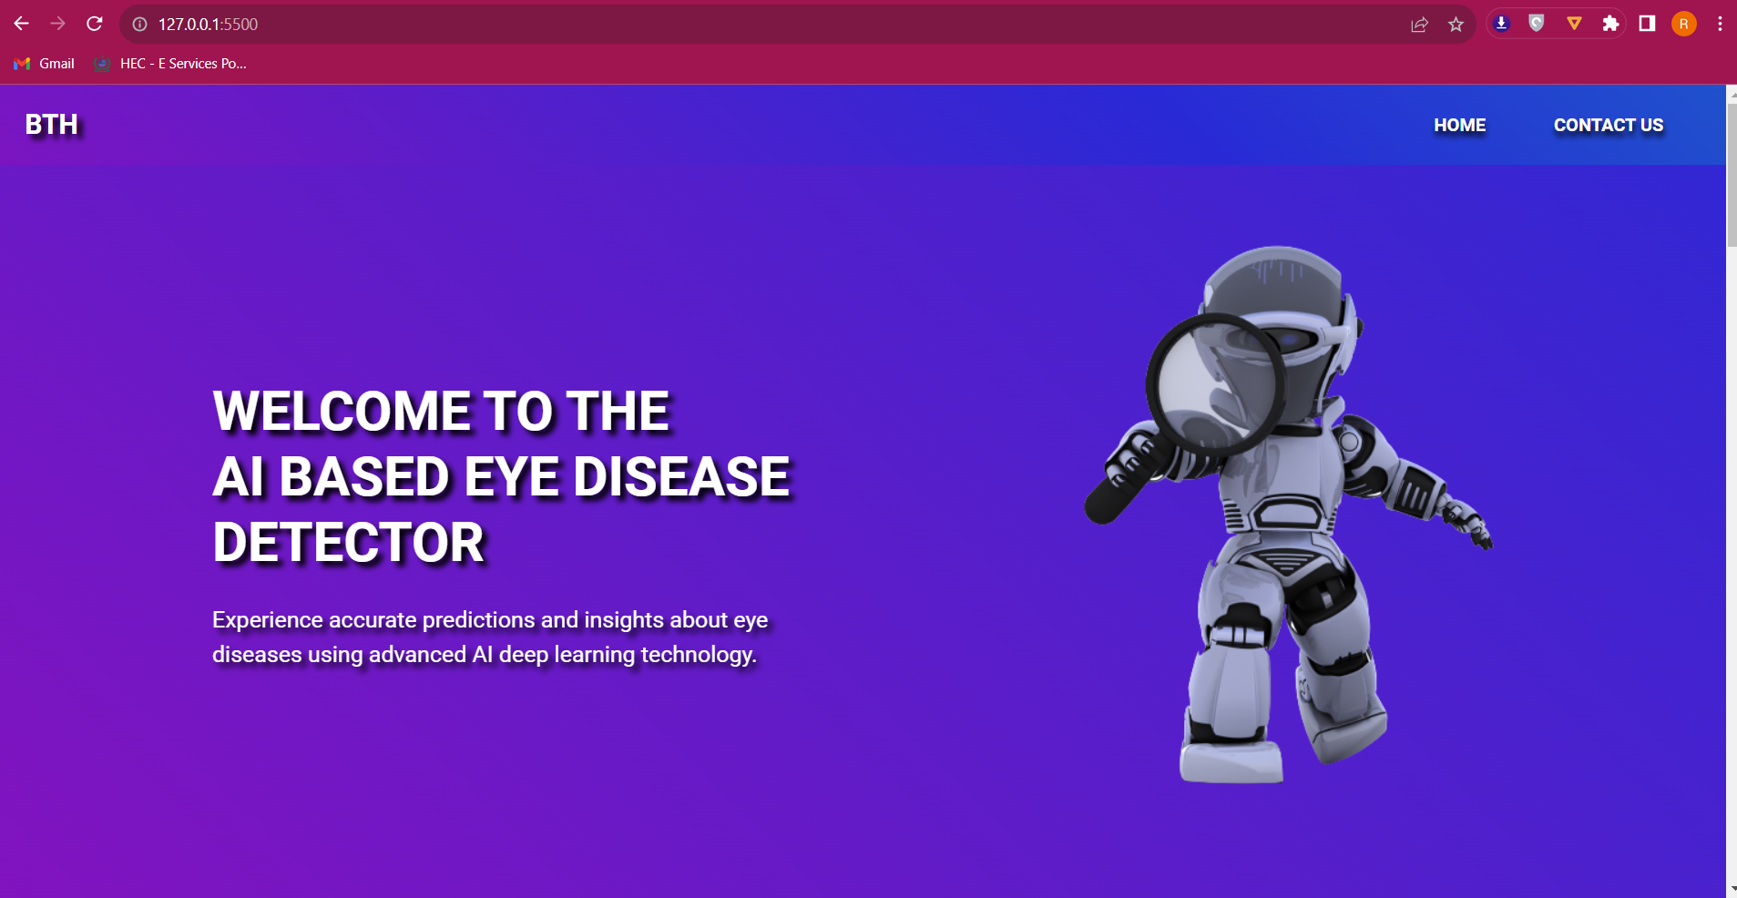

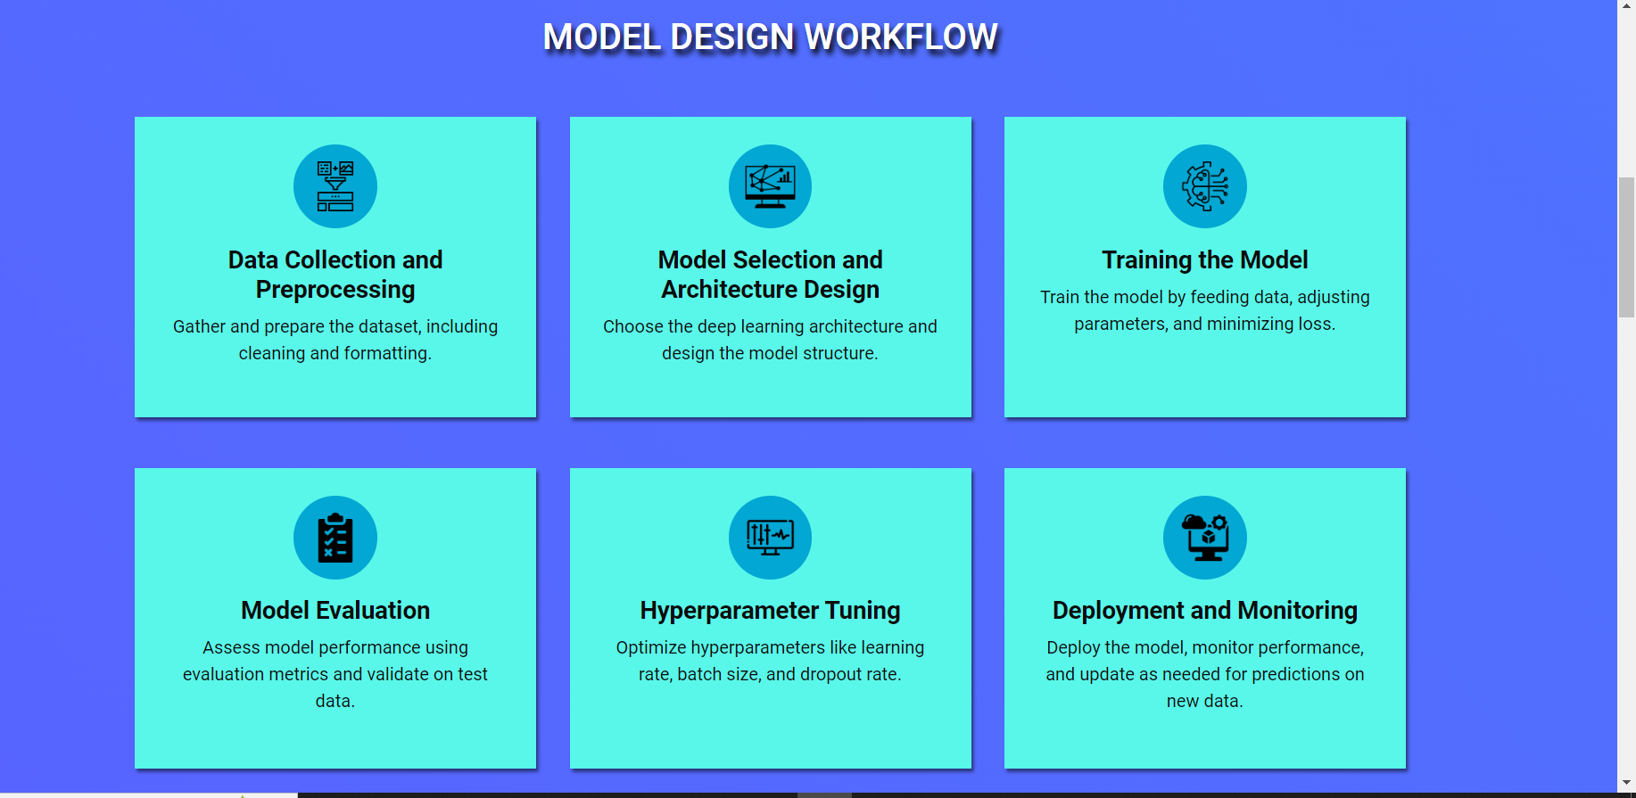

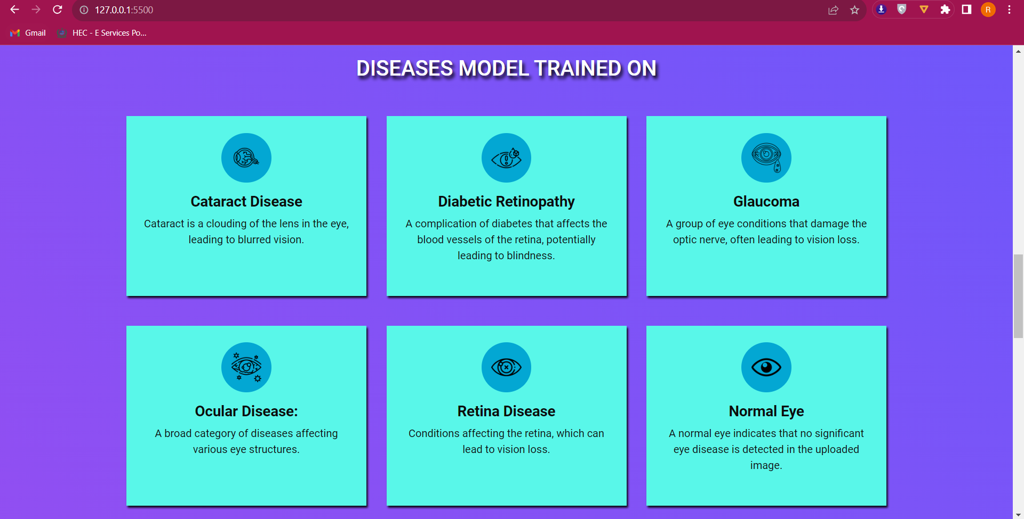

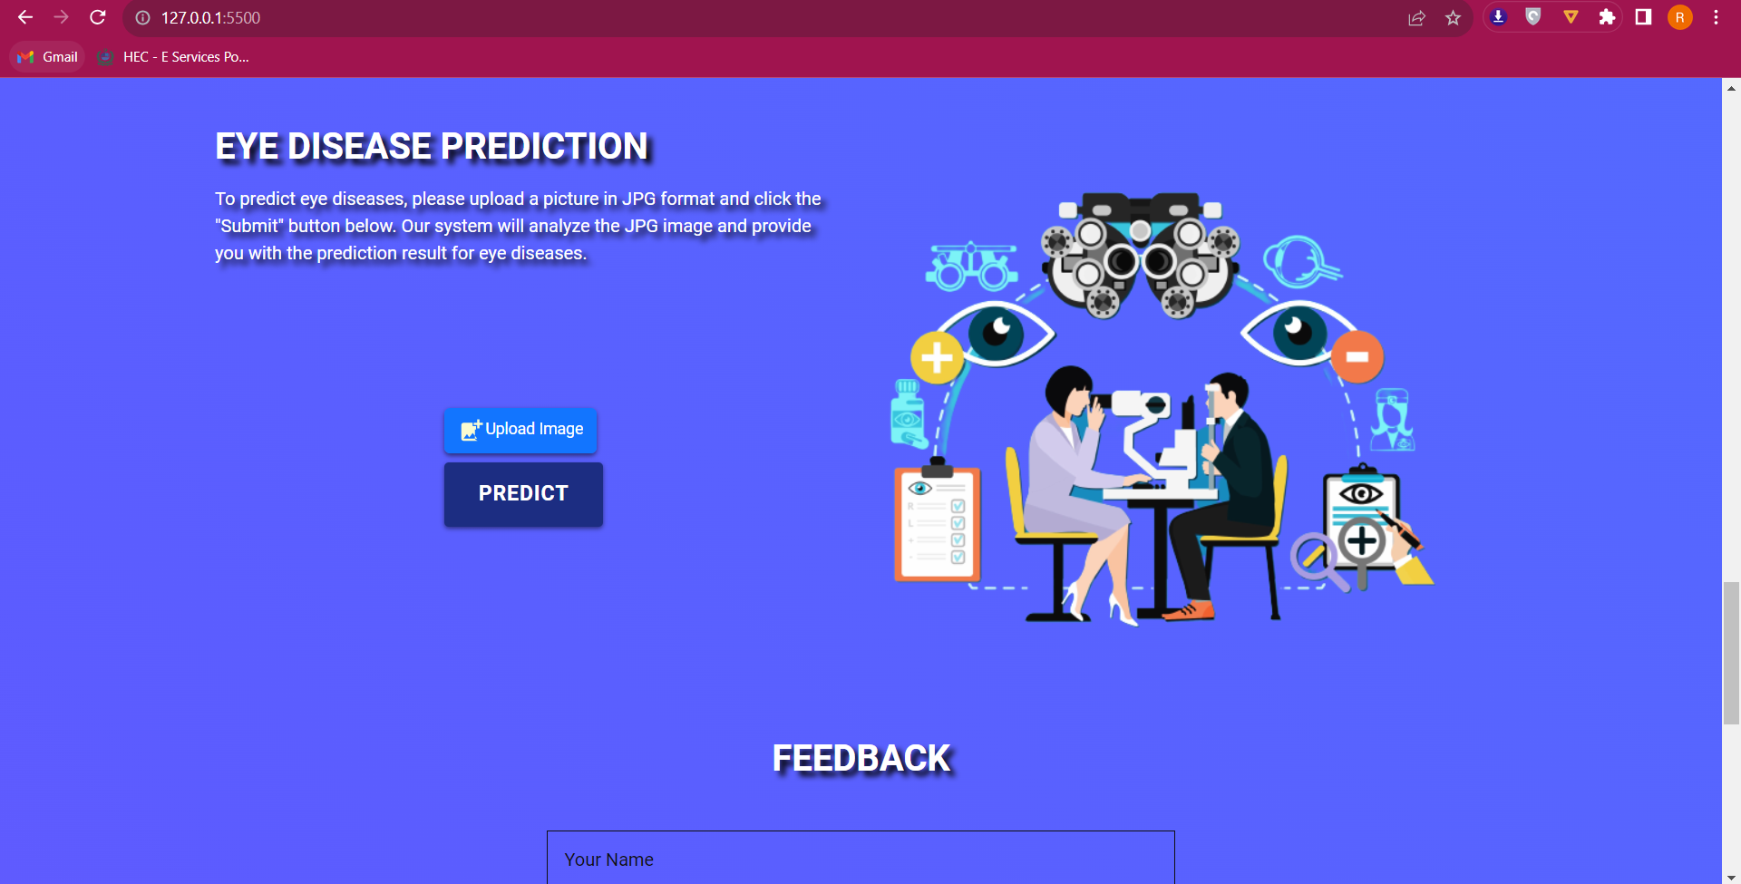

**Here we upload a image for prediction**

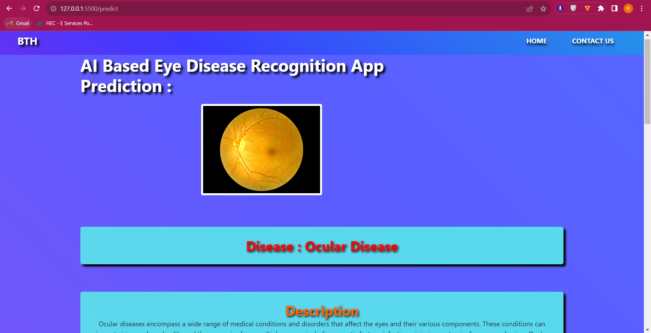

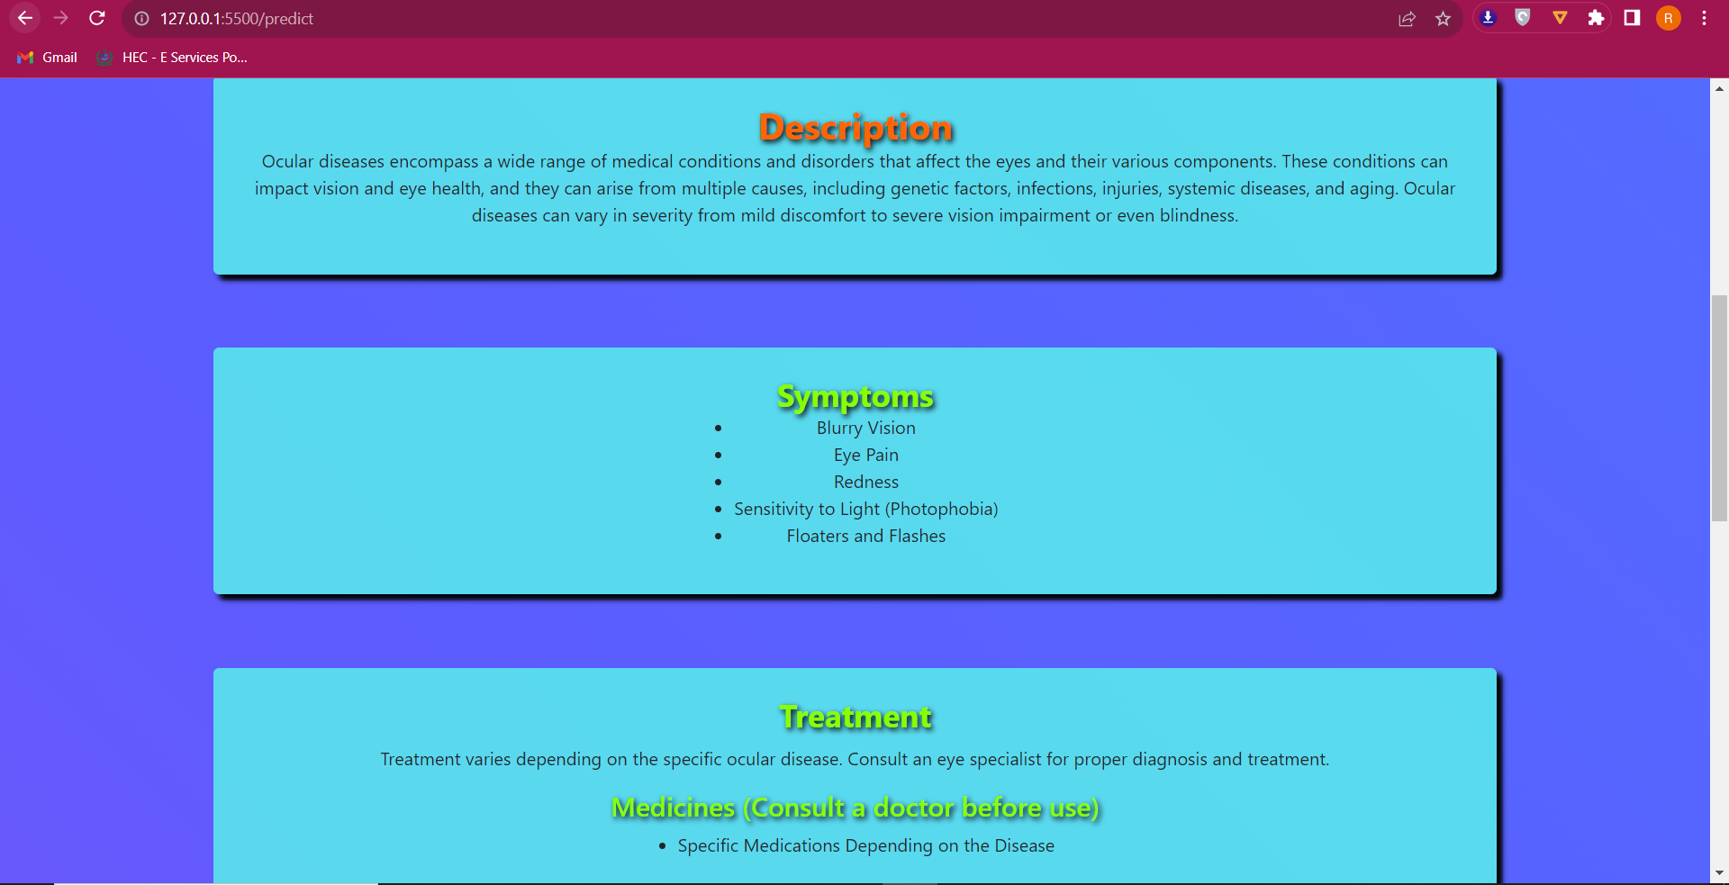

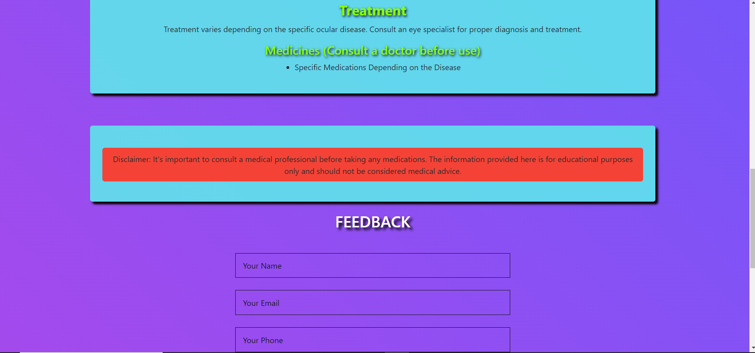

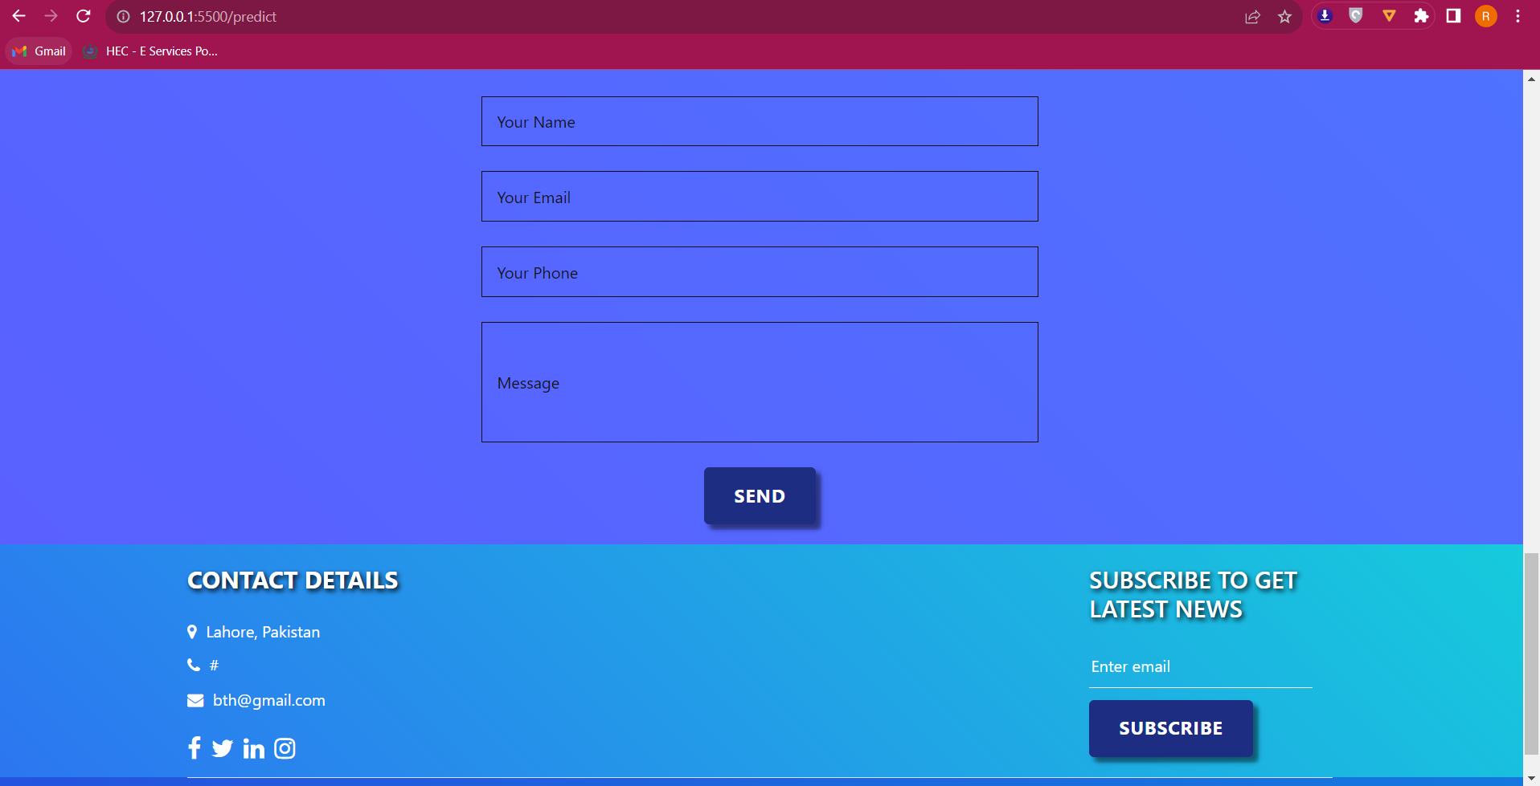

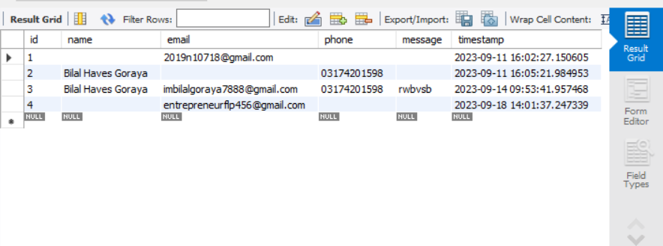

**Feedback stored in MySQL database**

**Discussion:**

The successful development of an accurate eye disease recognition system is a significant advancement in the field of healthcare. Early disease detection can lead to timely interventions, ultimately improving patient outcomes and reducing the burden on healthcare providers.

**Challenges and Learnings:**

Throughout the project, we faced challenges related to data collection and model training. However, these challenges provided valuable learning experiences, enabling us to refine our skills in data preprocessing and deep learning.

**Conclusion:**

In conclusion, the "Eye Disease Recognition Project" has achieved its objectives by creating an accurate CNN model for recognizing five different eye diseases. The integration of this model into a user-friendly web application with database support enhances accessibility and usability. This project demonstrates the potential of AI-based healthcare solutions to improve patient care.

**Future Recommendations:**

Future work may involve expanding the model to recognize additional eye diseases, improving the user interface with telemedicine capabilities, and exploring partnerships with healthcare institutions for real-world implementation.

**Text Sentimental Analysis**

**Name: Bilal Javed Goraya**

**Roll_no:RP-20EE-407**

**Abstract:**

This report presents the process and results of performing sentiment analysis on a dataset of text data obtained from Kaggle. The objective of the project was to analyze each text and assign a corresponding sentiment label, namely positive, negative, or neutral. The project encompassed data collection, cleaning, preprocessing, feature engineering, model selection, and evaluation. This report outlines the methodology, key findings, and insights gained from the analysis.

**1.Introduction:**

Sentiment analysis involves determining the sentiment expressed in a piece of text, which is a fundamental task in natural language processing (NLP). The objective of this project was to perform sentiment analysis on a text dataset sourced from Kaggle, with the goal of classifying each text into one of three sentiment categories: positive, negative, or neutral.

**Example: Product Reviews on an Online Store**

Imagine you are working for an online store that sells various consumer products. The online store receives numerous product reviews from customers, expressing their thoughts and opinions about the products they purchased. Analyzing these reviews manually would be time-consuming and inefficient. This is where sentiment analysis comes in.

Consider the following product review:

Review: "I absolutely love this product! It exceeded my expectations and has made my daily routine so much easier."

In this example, the sentiment expressed in the review is clearly positive. A human reader can easily recognize the positive sentiment based on phrases like "absolutely love," "exceeded my expectations," and "easier." However, for a computer to understand and categorize this sentiment, it needs to follow a systematic process.

**Steps in Sentimental Analysis:**

* Data Cleaning and Preprocessing
* Exploratory Data Analysis(EDA)
* Tokenization
* Stemming/Lemmatisation
* Stop Words
* Feature Extraction through TF-IDF
* Model Selection
* Training Model
* Evaluation
* Deployment

**2.Data Collection and Cleaning :**

Data collection and cleaning serve as the cornerstone of any data analysis or machine learning endeavor. These initial steps are pivotal in setting the stage for the rest of the project. In this section, we'll delve into the significance of these steps and discuss the approach for collecting, cleaning, and preparing the data for further analysis. The selection of data involves following steps:

* Identify Problem
* Choose Data according to that problem
* Clean the data (Remove duplicated, Fill Null values with Mode, Mean etc.)
* Removing Punctuation and number’s (Text Analysis case)
* Visualize Data
* Correlation hunting

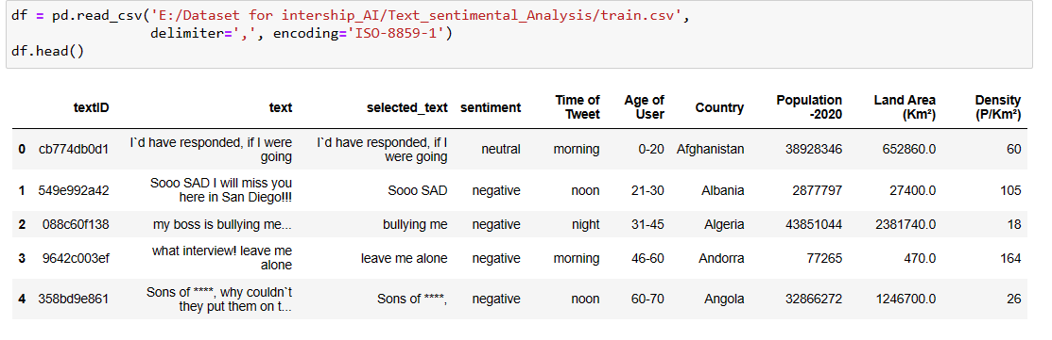

**Figure 1 Data collection for Sentimental Analysis**

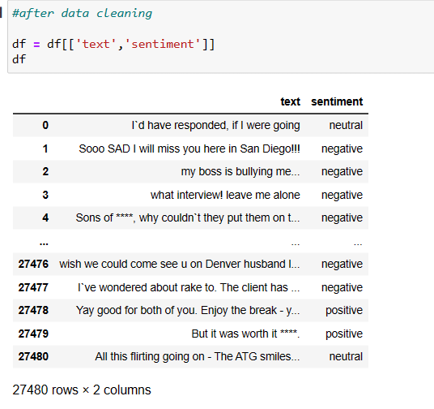

**Figure 2 Data cleaning for Sentimental Analysis**

The data which we need for our problem is Text Base data and that Data is the tweet data for many users which is basically a Social Media base data which is shown in figure 1 above. It has 6 Columns in which there is a,

* textID
* text
* text_selected
* sentiment
* Time of Tweet
* Age of user
* Country
* Population
* Land area
* Density

During the Cleaning I first check whether there is any NULL value or Duplicates in the data through the following command,

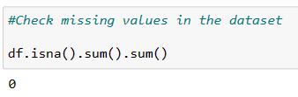

**Figure 3 Checking Null and missing values**

**3.Data Preprocessing:**

Text Preprocessing is traditionally an important step for Natural Language Processing (NLP) tasks. It transforms text into a more digestible form so that machine learning algorithms can perform better.

The Preprocessing steps taken are:

**1.Lower Casing:** Each text is converted to lowercase.

**2.Replacing URLs:** Links starting with "http" or "https" or "www" are replaced by "URL".

**3.Replacing Emojis:** Replace emojis by using a pre-defined dictionary containing emojis along with their meaning. (eg: ":)" to "EMOJIsmile")

**4.Replacing Usernames:** Replace @Usernames with word "USER". (eg: "@Kaggle" to "USER")

**5.Removing Non-Alphabets:** Replacing characters except Digits and Alphabets with a space.

**6.Removing Consecutive letters:** 3 or more consecutive letters are replaced by 2 letters. (eg: "Heyyyy" to "Heyy")

**7.Removing Short Words:** Words with length less than 2 are removed.

**8.Removing Stopwords:** Stopwords are the English words which does not add much meaning to a sentence. They can safely be ignored without sacrificing the meaning of the sentence. (eg: "the", "he", "have")

**9.Lemmatizing:** Lemmatization is the process of converting a word to its base form. (e.g: “Great” to “Good”)

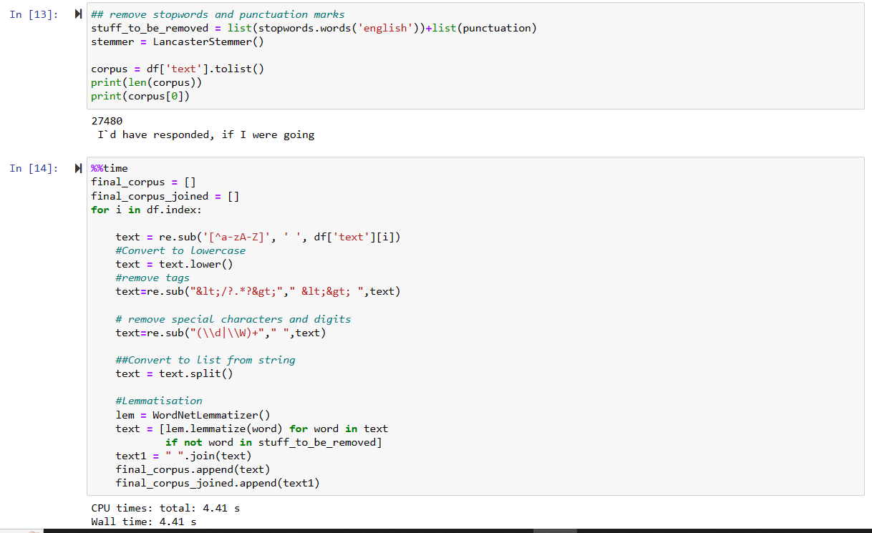

**Figure 4 data preprocessing**

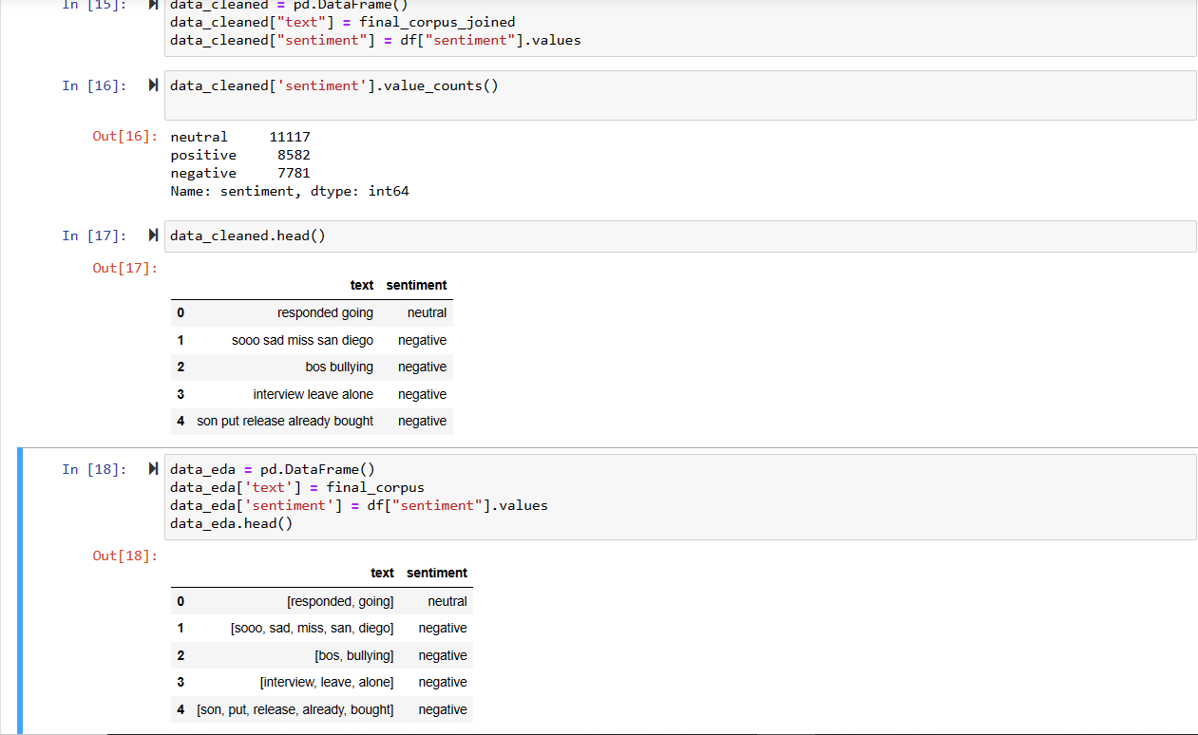

**Fig 5 also data preprocessing**

**4.Exploratory Data Analysis (EDA):**

In this process we have to Visualize our data which give us an insight knowledge about our data. It is not possible for humans to read all the rows and columns of data set. So to make it easy we use Graphs to see the behavior or pattern in the data. It helps us in following,

* Visualization of word frequency to identify common words.
* Analysis of sentiment label distribution to understand class imbalances.
* Creation of word clouds to visualize sentiment-specific word usage.

**Word frequency:**

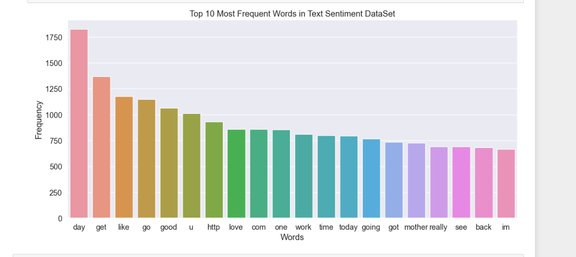

**Figure 6 Most frequent words**

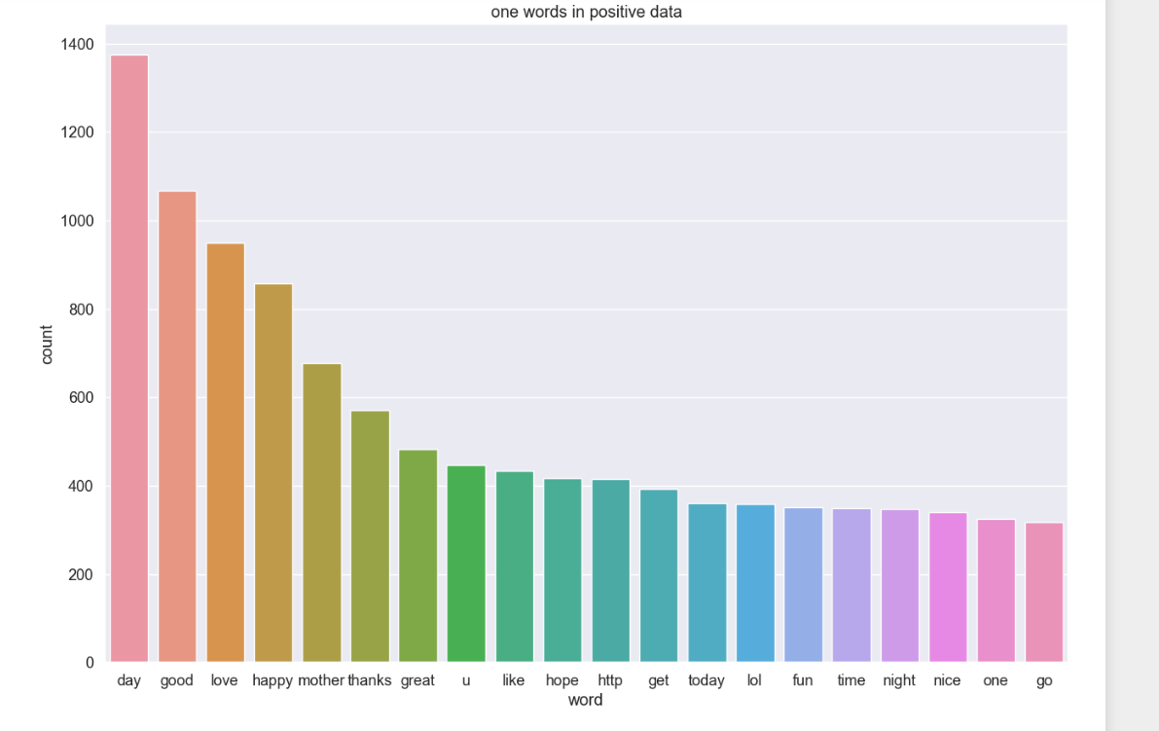

**Figure 7 positive frequent words**

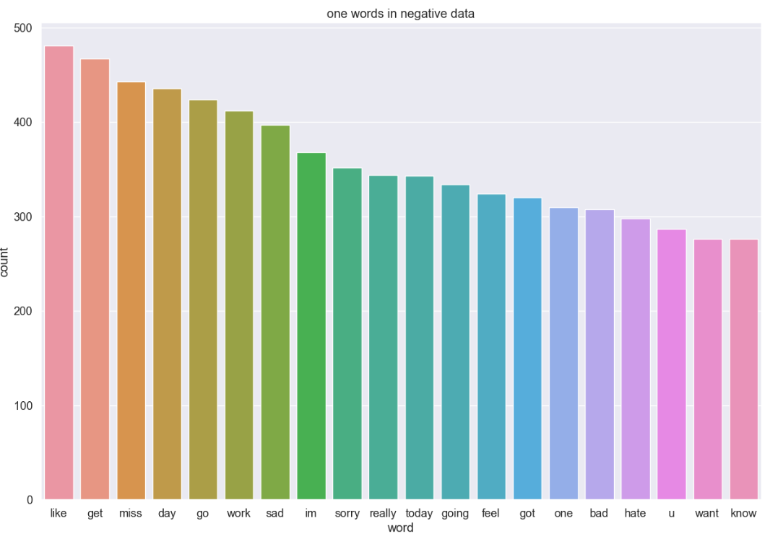

**Figure 8 negative frequent words**

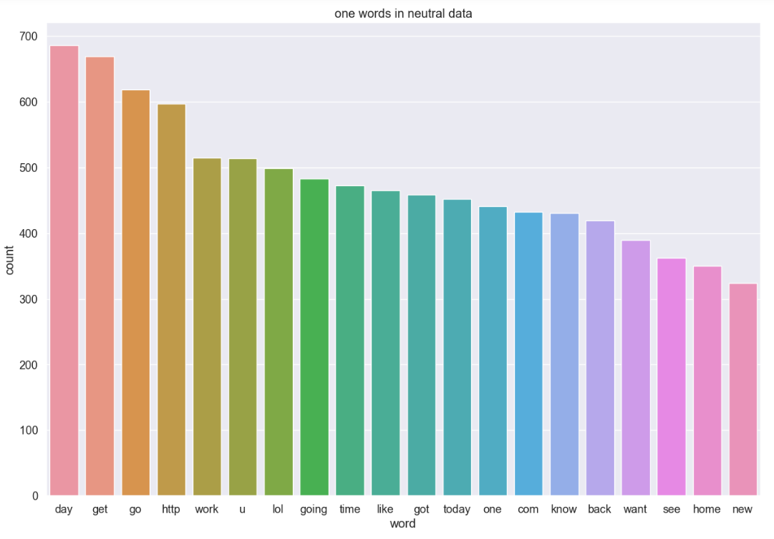

**Figure 9 neutral frequent words**

**Sentiment Distribution:**

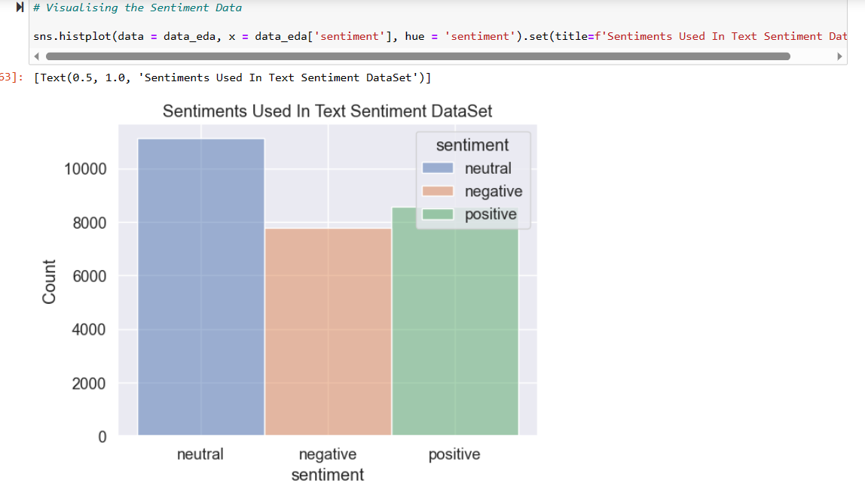

**Figure 10 sentiment distribution**

**WordClouds:**

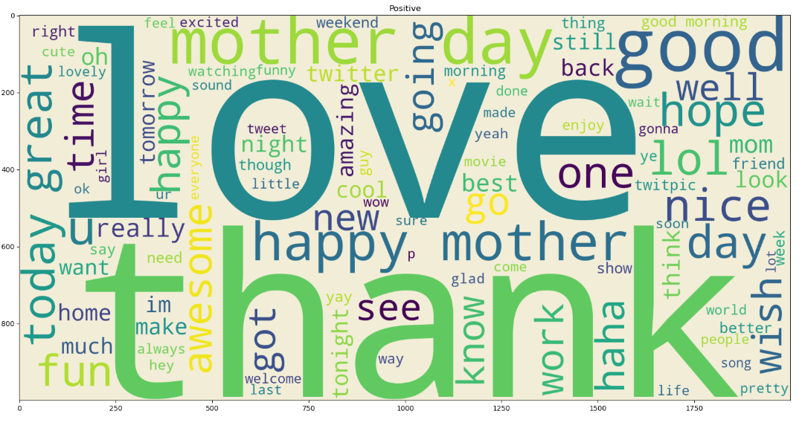**Figure 11 wordcloud for positive texts**

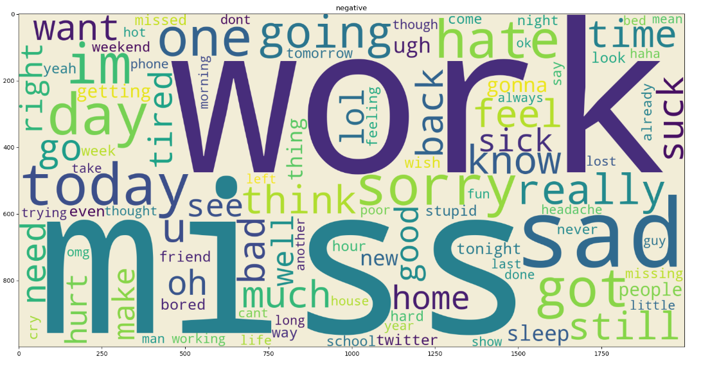

**Figure 12 wordcloud for negative texts**

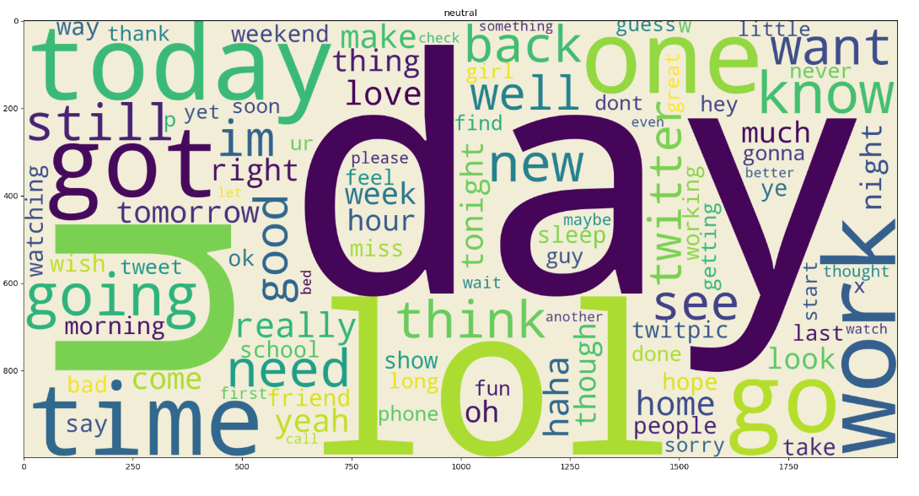

**Figure 13 wordcloud for neutral texts**

**5.Feature Engineering:**

TF-IDF stands for Term Frequency-Inverse Document Frequency. It's a numerical representation used in natural language processing and information retrieval to evaluate the importance of words in a document within a collection of documents (corpus). TF-IDF is particularly useful for feature engineering in text analysis tasks like text classification, sentiment analysis, and information retrieval.

Here's how TF-IDF works:

1.Term Frequency (TF): This measures how often a word appears in a specific document. It's calculated as the ratio of the number of times a word (term) appears in the document to the total number of words in that document. The idea is that words appearing frequently within a document are likely to be important to the document's content.

TF = (Number of times the term appears in the document) / (Total number of words in the document)

2.Inverse Document Frequency (IDF): This measures the rarity of a word across all documents in the corpus. Words that appear in many documents are considered less informative, while words that appear in fewer documents are given higher weight. IDF is calculated as the logarithm of the total number of documents divided by the number of documents containing the term.

IDF = log((Total number of documents) / (Number of documents containing the term))

3.TF-IDF: The TF-IDF score for a term in a specific document combines both the term's frequency in that document (TF) and its rarity across all documents (IDF). The higher the TF-IDF score, the more important the term is to the document's content.

TF-IDF = TF * IDF

TF-TDF performs various tasks which are given below:

* Convert text into Tokens
* Lower case the text and remove punctuations by default
* Calculate how many times a word occurs in document
* Find the Importance of that word in the Document
* Make a Vector based on above operations which have score of each word

The important point here is that we should do first 4 steps before feature extraction otherwise he counts “is”, “am” or other words which are irrelevant which effects our accuracy score of model.

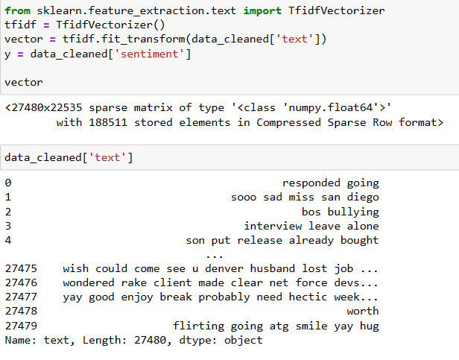

**Figure 14 Feature Extraction from data**

**6.Model Selection:**

The choice of model influences the accuracy of sentiment classification. We consider traditional machine learning models like Logistic Regression and Support Vector Machines, along with deep learning models like Recurrent Neural Networks and Transformers.. Selection of right model is depending on the following things,

* Type of Problem (Regression, Classification, Clustering)
* Nature of data
* Data Size
* Data Complexity
* Computation Time and Cost
* Scalability

**Machine Learning Models:**

**Logistic Regression:** This simple yet effective model is often used as a baseline. It's suitable when the dataset is not overly complex and linear separability is reasonable.

**Support Vector Machines (SVM):** SVMs can handle non-linear relationships between features and labels. They work well for sentiment analysis tasks with a clear margin of separation between sentiment classes.

**Deep Learning Models:**

Recurrent Neural Networks (RNNs): RNNs are suitable for sequential data like text. They can capture contextual information and are effective when word order matters. However, they might struggle with long-range dependencies.

Transformers (e.g., BERT, GPT): Transformers have revolutionized NLP tasks. BERT, for example, is a pre-trained language model that excels in capturing contextual information and relationships between words. Fine-tuning BERT for sentiment analysis can yield excellent results.

**7.Results:**

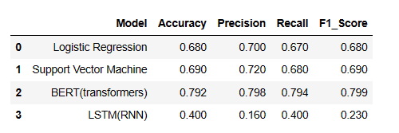

**8.Insights:**

**Word Importance:** Through feature analysis (e.g., TF-IDF), you might discover which words contribute most to positive or negative sentiments. This insight can provide a glimpse into what specific factors drive sentiments.

**Word Associations:** Analyzing word co-occurrences can reveal interesting associations. For example, certain words might frequently appear with positive sentiment words, suggesting common positive contexts.

**Sentiment Trends:** Over time, you might notice shifts in sentiment. For instance, positive sentiments might peak during holidays or product launches, while negative sentiments could coincide with issues.

**Text Complexity:** Depending on your dataset, you might find that the complexity of language influences sentiment. Longer sentences or complex vocabulary could indicate more nuanced sentiment expressions.

**Sentiment Balance:** Understanding the distribution of sentiments in your dataset can provide insights into how positive, negative, and neutral sentiments are distributed. This can be useful for understanding user preferences or market trends.

**9.Challenges and Solutions:**

**1.Imbalanced Data:**

If the dataset has a significant class imbalance (e.g., more positive than negative samples), the model might become biased towards the majority class. Solution: Implement techniques like oversampling, undersampling, or using different evaluation metrics that account for class imbalance.

**2.Sarcasm and Irony:**

Sentiments conveyed through sarcasm or irony can be challenging for models to accurately interpret. Solution: Incorporate contextual information, advanced sentiment analysis models, or sentiment lexicons that capture nuanced language.

**3. Contextual Understanding:**

Some words might have different sentiments based on context. For instance, "bad" can refer to product quality or imply a negative experience. Solution: Utilize models like BERT or other contextual embeddings that capture word meaning in context.

**4.Domain Specificity:**

Sentiment expressions can vary across domains, and models trained on one domain may not perform well on another. Solution: Fine-tune or train models on domain-specific data to capture domain-specific sentiment patterns.

**5.Data Noise:**

Noisy text data with typos, slang, and grammatical errors can affect model performance. Solution: Implement robust text preprocessing techniques, possibly using spell-checkers and language correction tool

**10.Suggestions for Future Improvements or Extensions:**

**1.Aspect-based Sentiment Analysis:**

Instead of treating the entire text as a single sentiment, analyze sentiment towards specific aspects/entities mentioned in the text. This provides more detailed insights.

**2.Multilingual Sentiment Analysis:**

Extend the project to handle sentiment analysis in multiple languages, which can be valuable for global applications.

**3.Emotion Analysis:**

Go beyond binary sentiment classification and explore detecting specific emotions like joy, anger, sadness, etc.

**4.Real-time Sentiment Monitoring:**

Develop a system that can analyze and visualize real-time sentiment from social media or user-generated content.

**5.Ensemble Models:**

Combine multiple sentiment analysis models (e.g., TF-IDF, word embeddings, BERT) using ensemble techniques to improve overall accuracy.

**6.Explainable AI:**

Investigate methods to make the model's predictions more interpretable, such as generating explanations for why certain sentiments were predicted.

**7.Fine-grained Sentiment Analysis:**

Instead of just positive/negative sentiment, consider fine-grained sentiment levels like strongly positive, mildly positive, neutral, mildly negative, strongly negative.

**8. User Interface:**

Create a user-friendly interface or application where users can input text and get sentiment predictions along with visualization of sentiment trends.

**9.Active Learning:**

Implement active learning strategies to iteratively select and label the most informative samples for model improvement, reducing the labeling effort.

**10.Continuous Learning:** Set up a pipeline for continuous learning, allowing the model to adapt and improve over time as new labeled data becomes available.